Coefficients:

Estimate Std. Error z value Pr(>|z|)

(Intercept) 1.576e-01 2.531e-02 6.228 4.74e-10 ***

LOCATIONH 2.750e-02 1.157e-02 2.376 0.0175 *

PERIOD2 -3.190e-02 1.617e-02 -1.972 0.0486 *

PERIOD3 7.775e-03 1.609e-02 0.483 0.6289

PERIOD4 -2.358e-02 1.662e-02 -1.419 0.1559

PERIOD5 -1.701e-01 7.142e-02 -2.382 0.0172 *

PERIOD6 1.107e-01 1.607e-01 0.689 0.4908

PERIOD7 -1.294e-01 3.232e-01 -0.400 0.6889

GAME_CLOCK -1.997e-05 2.850e-05 -0.701 0.4834

SHOT_CLOCK 1.561e-02 9.899e-04 15.767 < 2e-16 ***

DRIBBLES 3.192e-02 4.630e-03 6.894 5.41e-12 ***

TOUCH_TIME -6.305e-02 5.463e-03 -11.541 < 2e-16 ***

SHOT_DIST -6.403e-02 1.104e-03 -57.972 < 2e-16 ***

PTS_TYPE3 8.392e-02 2.028e-02 4.138 3.51e-05 ***

CLOSE_DEF_DIST 1.016e-01 2.728e-03 37.264 < 2e-16 ***

VIF test:

GVIF Df GVIF^(1/(2*Df))

LOCATION 1.000307 1 1.000153

PERIOD 1.020336 6 1.001679

GAME_CLOCK 1.037235 1 1.018447

SHOT_CLOCK 1.091346 1 1.044675

DRIBBLES 7.487541 1 2.736337

TOUCH_TIME 7.617480 1 2.759978

SHOT_DIST 2.797688 1 1.672629

PTS_TYPE 2.303526 1 1.517737

1.569876 1 1.252947

Remove PTS_TYPE, TOUCH_TIME, GAME_CLOCK:

Coefficients:

Estimate Std. Error z value Pr(>|z|)

(Intercept) 0.0166469 0.0210611 0.790 0.4293

LOCATIONH 0.0272171 0.0115509 2.356 0.0185 *

PERIOD2 -0.0280839 0.0161253 -1.742 0.0816 .

PERIOD3 0.0121570 0.0160497 0.757 0.4488

PERIOD4 -0.0162074 0.0165541 -0.979 0.3276

PERIOD5 -0.1575079 0.0710317 -2.217 0.0266 *

PERIOD6 0.1106633 0.1603299 0.690 0.4901

PERIOD7 -0.1340025 0.3239996 -0.414 0.6792

SHOT_CLOCK 0.0175909 0.0009664 18.203 <2e-16 ***

DRIBBLES -0.0183777 0.0017226 -10.669 <2e-16 ***

SHOT_DIST -0.0606711 0.0008297 -73.121 <2e-16 ***

CLOSE_DEF_DIST **0.1036243** 0.0027235 38.048 <2e-16 ***

VIF test:

GVIF Df GVIF^(1/(2*Df))

LOCATION 1.000254 1 1.000127

PERIOD 1.006740 6 1.000560

SHOT_CLOCK 1.046005 1 1.022744

DRIBBLES 1.038423 1 1.019030

SHOT_DIST 1.581730 1 1.257668

CLOSE_DEF_DIST 1.568188 1 1.252273

Location:

LOCATION `mean(FGM)`

A 0.4484133

H 0.4565350

Period:

PERIOD `mean(FGM)`

1 0.4605283

2 0.4511074

3 0.4571420

4 0.4400989

5 0.3903509

6 0.4345238

7 0.3720930

Shot Clock:

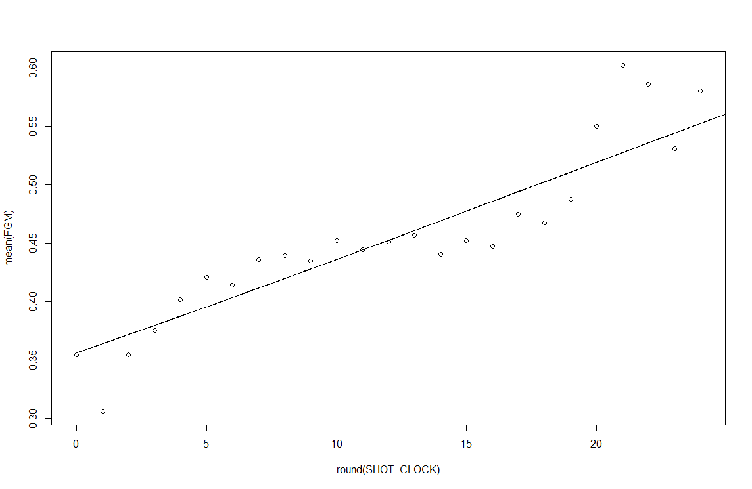

Dribbles:

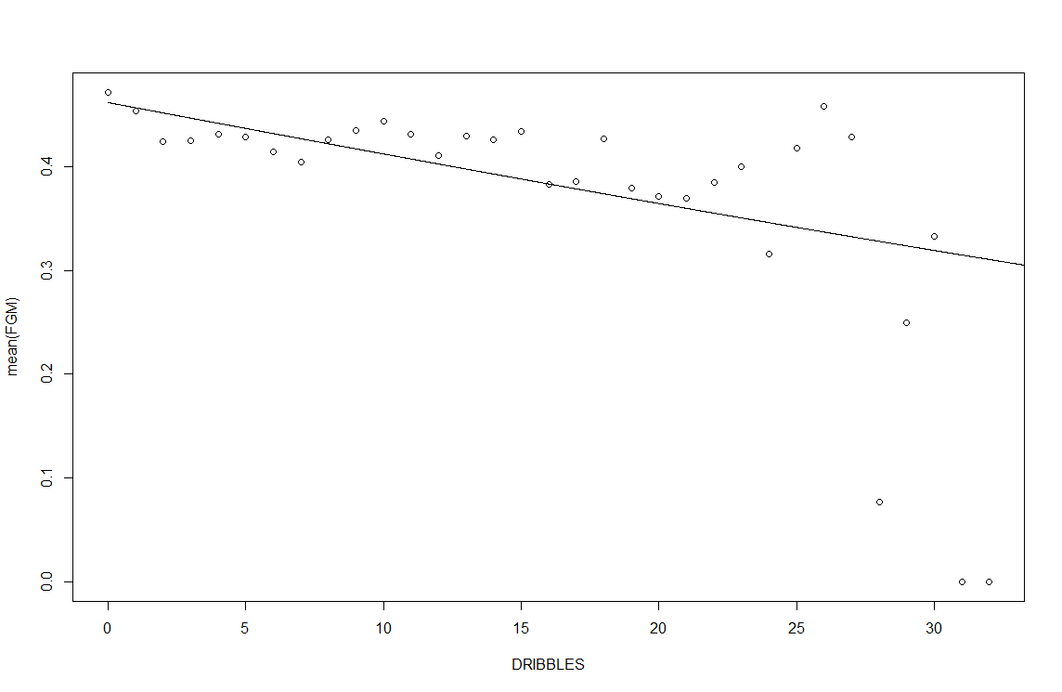

Shot Distance:

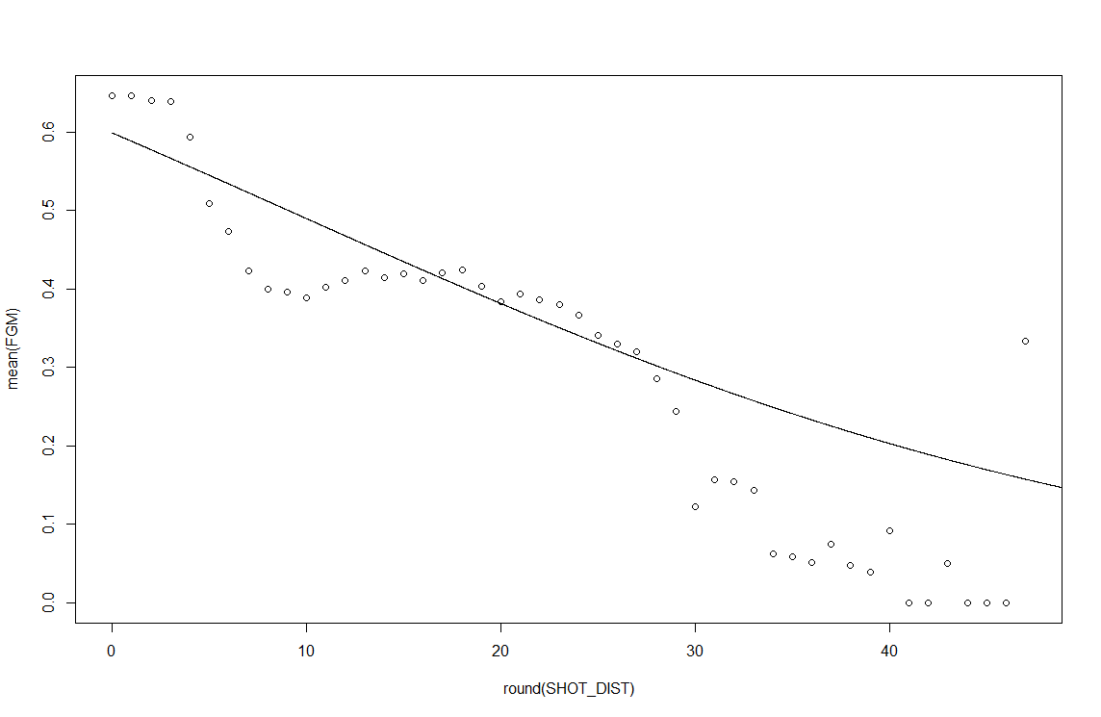

PTS_TYPE `mean(FGM)`

2 0.4888506

3 0.3515406

Closest Defender distance

